A

Report

On

Teacher’s Day 2024

Department of PHILOSOPHY

Rabindra Mahavidyalaya,

champadanga,hooghly

Session: 2024-25

Theme: TEACHERS DAY & NABIN BARAN

Venue: Department of PHILOSOPHY

Rabindra Mahavidyalaya, champadanga,

room no. 71

Date: 29/10/2024

Organizer: Department of Philosophy

Objectives:

- It is a reminder of the role that teachers play in nation-building by guiding and educating the brightest minds of our country.
- To promote good relationship between teachers and students.
- To Respect the teacher's values
- Helping them adapt to the new environment.

- To foster cordial relationship with students’

- To introduce about course, examination structure, evaluation system etc.

Summary

A Nabin Baran & Teacher’s Day is organized by the students of Philosophy Department on 29/10/2024.The program began auspiciously with the lighting of the lamp and garlanding by Professor Soumitra Das (head of the department) and prof. Sukla Saha, prof. Sourish Dey and prof. Sanchita Kheto(department prof.) in front of the portrait of Dr. Sarvepalli Radhakrishnan. Principal Sir appeared in the middle of the program and gave his valuable speech. A Freshers welcome is organized by the Department of Philosophy On that day. Current students welcomed the freshers with flowers and drops of sandalwood. Freshers are introducing to current students. Students are encouraged to uphold the tradition, dignity of this institution. Students perform a bunch of cultural programs, such as recitals, dances, songs, speeches etc. are also held. They perform very beautifully. Another departmental professor, non-teaching stuffs, Liberian was present and their presence added to the charm of the event. Everyone enjoys it very much. Through various programs they try to show respect and gratitude to teachers.

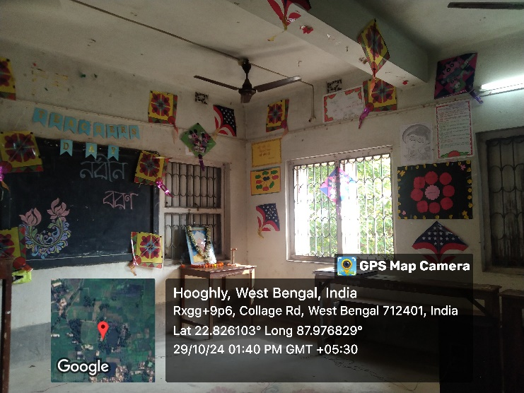
Decoration of teacher’s day
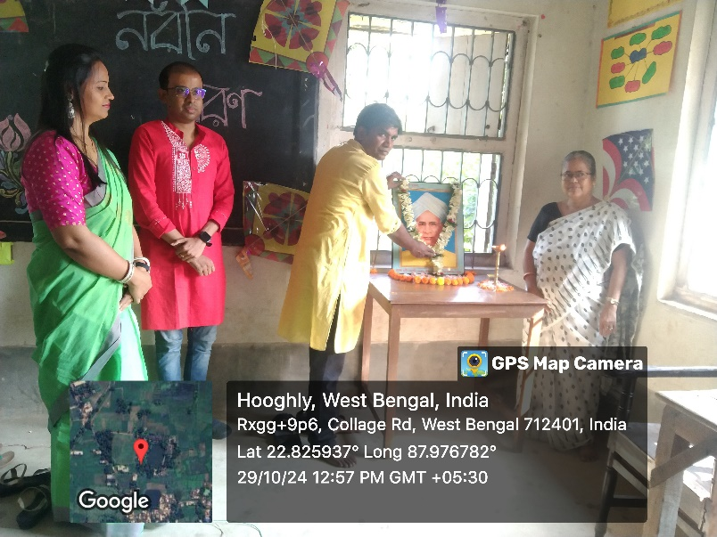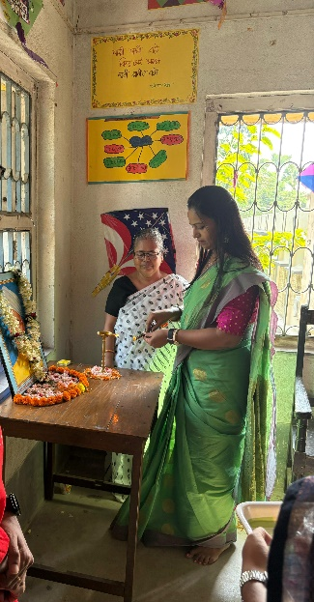
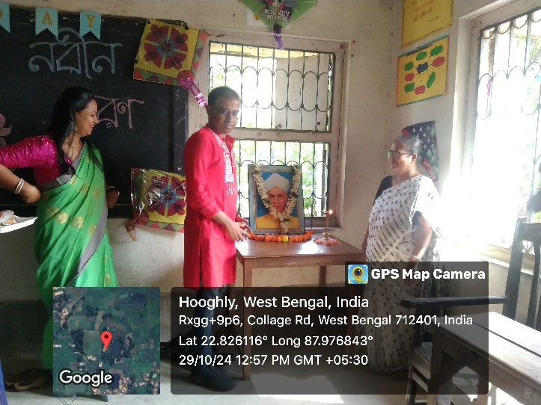
Inaugration by teachers
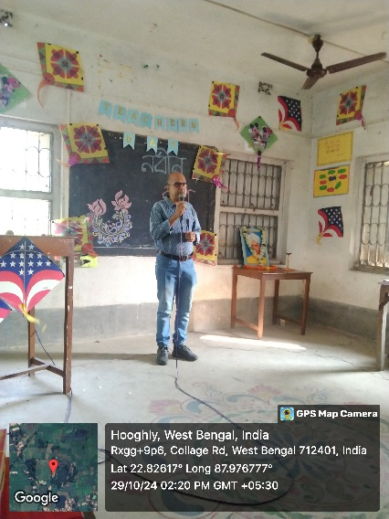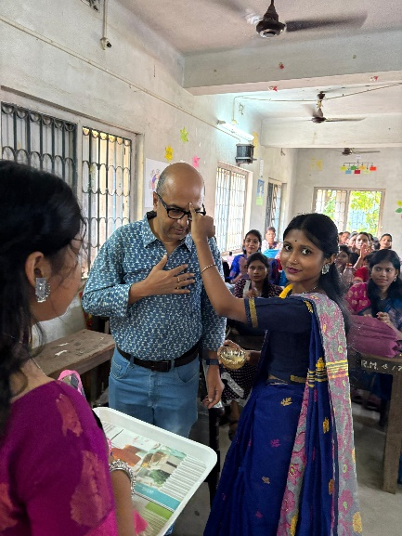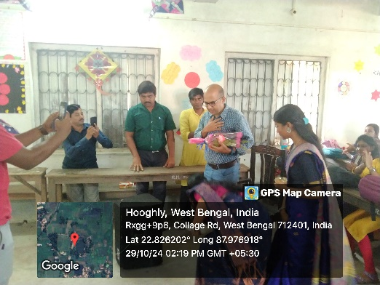
Speech by principal
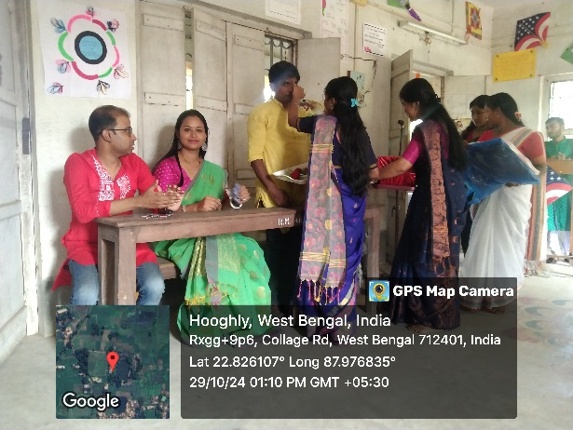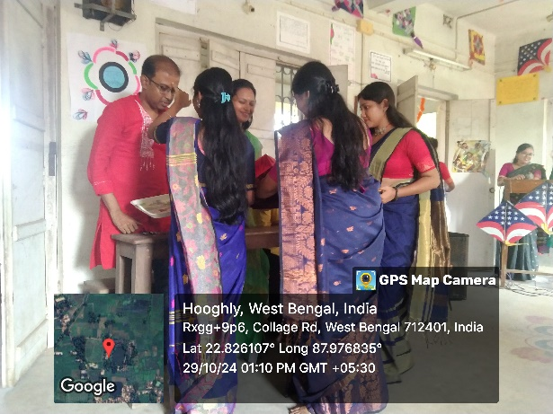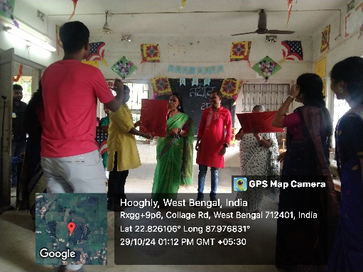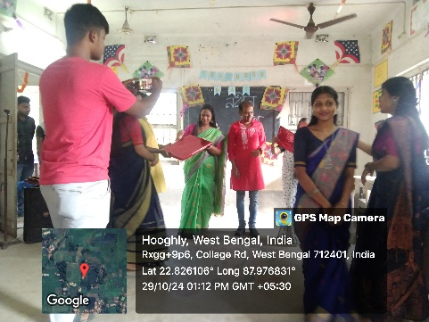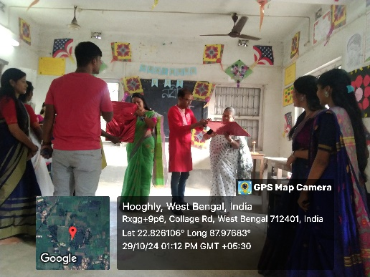
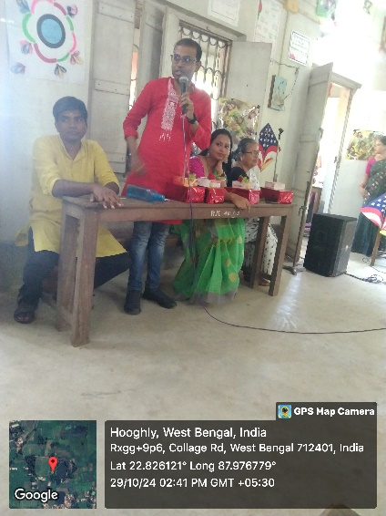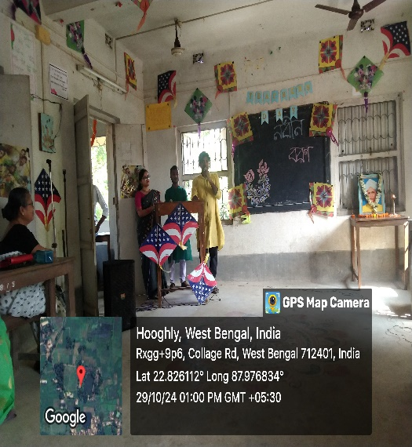
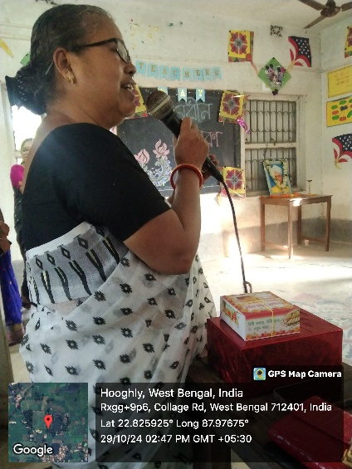
Speech by professors department of philosophy
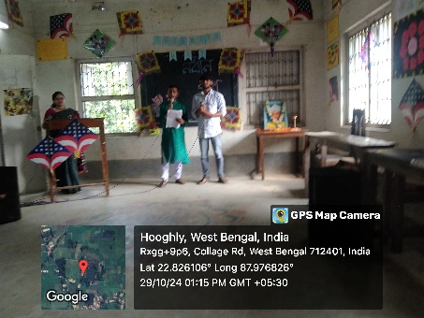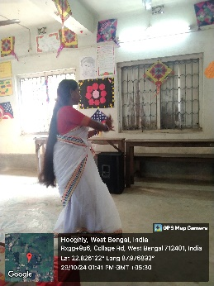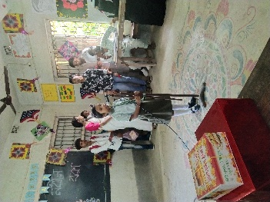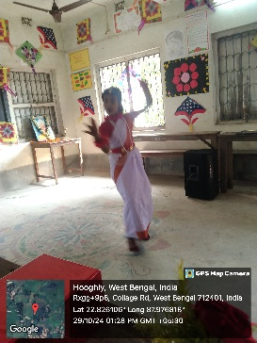
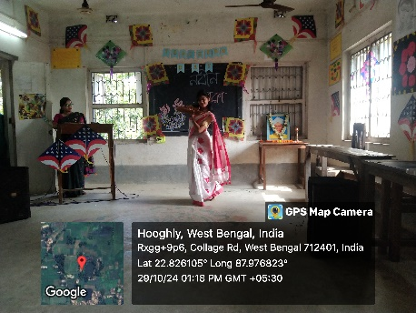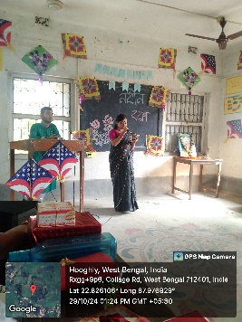
Perfomance by the students
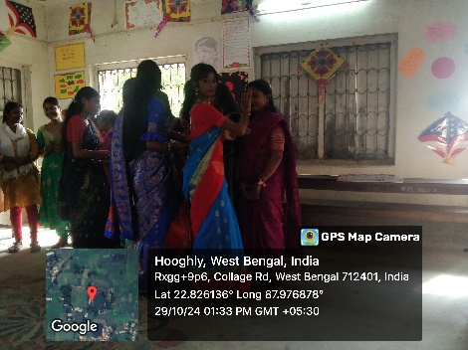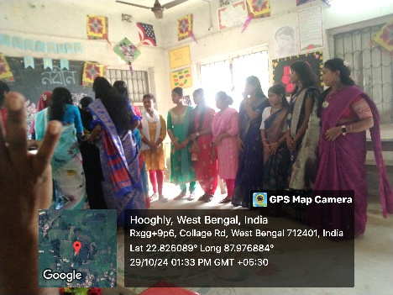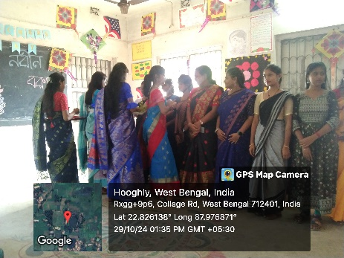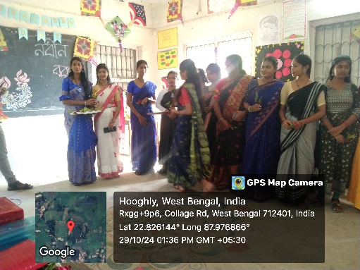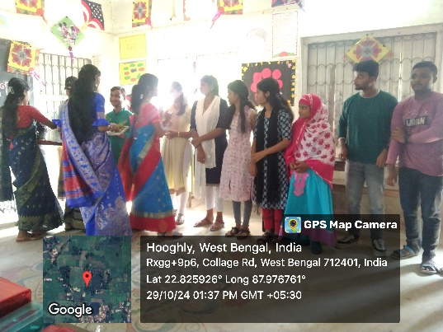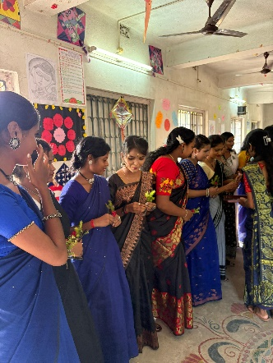
Nabin baran
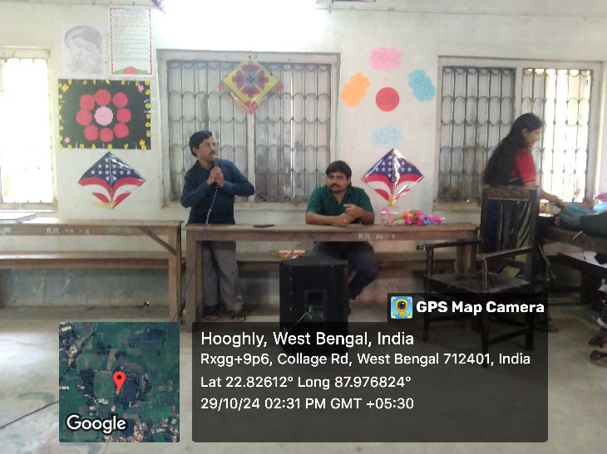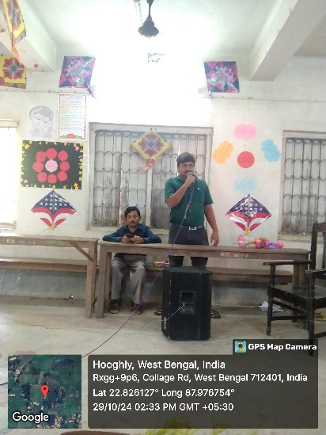
Speech by Liberian
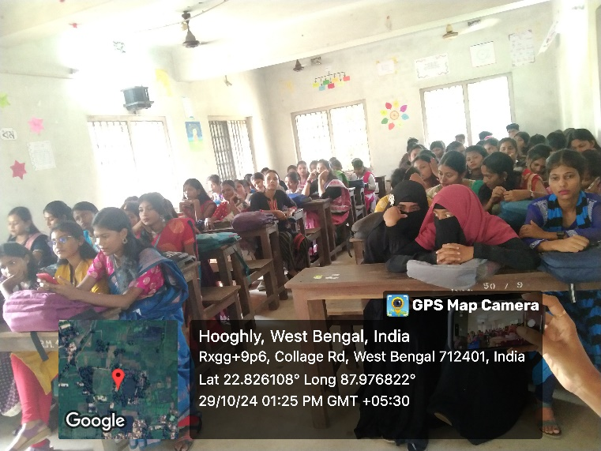
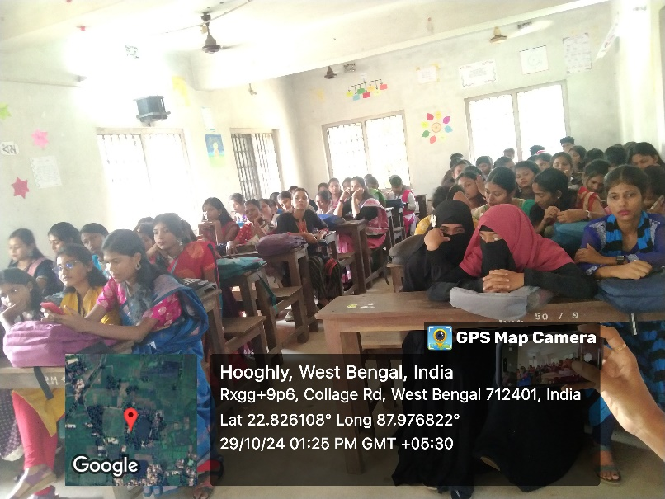
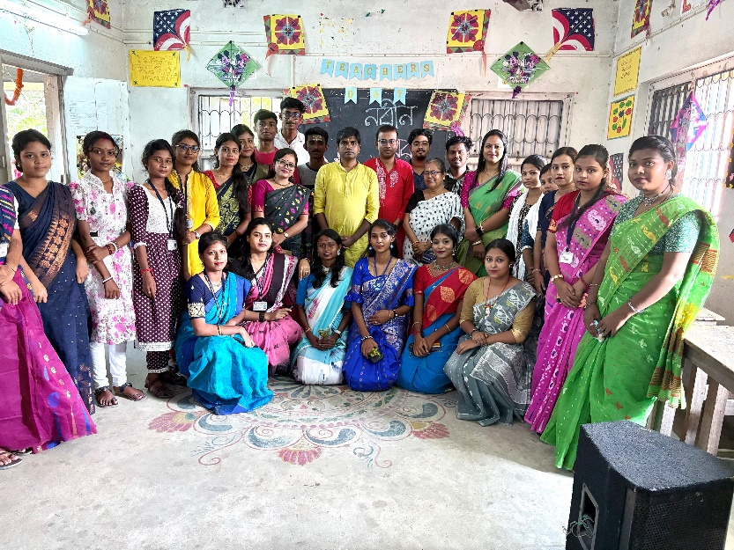
Our students
Our perticipent: 80
Male:20
Female:60

Tentative programme schedule
- Inaugural session: 12 :30p.m. to 1.00 p.m.
- Inaugural Speech: 1:00 p.m. to 1.20 p.m.
- Nabin baran: 1.20p.m. to 1.40p.m.
- Cultural programme: 1:40 p.m. to 2:40 p.m.

